**CMPE 256: HACKATHON**

**TEAM MEMBERS:** RUCHITHA REDDY KOLUGURI, HARSHAVARDHAN VALMIKI, SURESH RAVURI

**FINANCE MINISTER:** <https://chat.openai.com/g/g-cJuUtKu2G-finance-minister>

**1.Prompt That We Used:** What is the economic conditions of State and Central Government?

**Shared Chat for Reference:** <https://chat.openai.com/share/d88a5c68-9ae0-4314-9d2f-9e7761fdb82e>

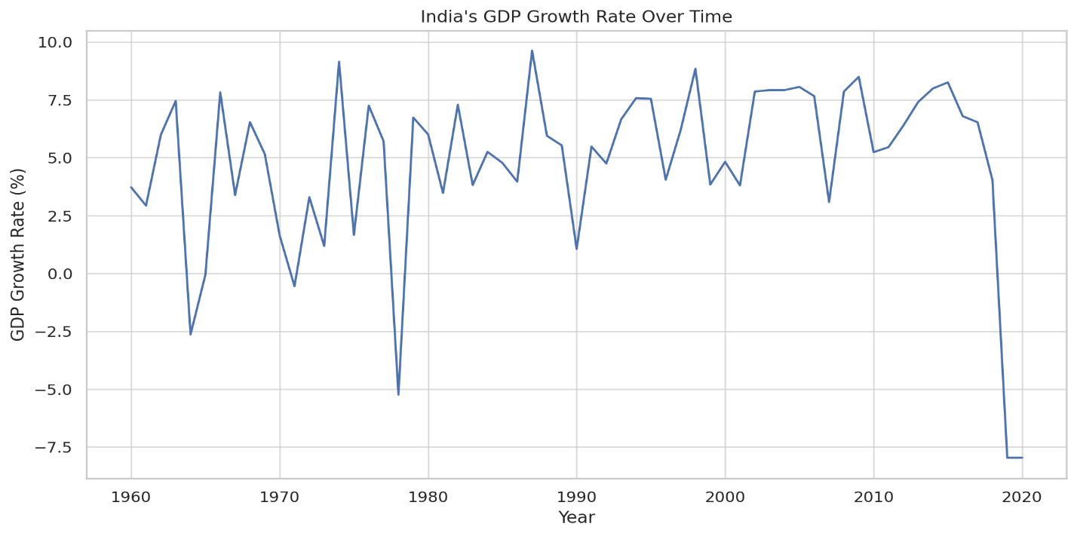

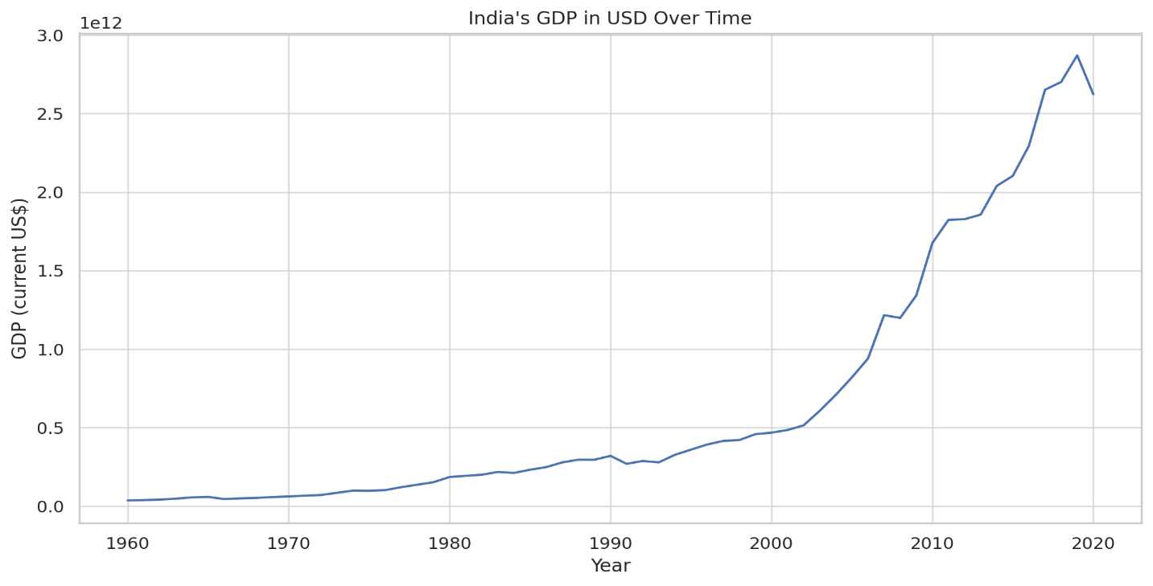

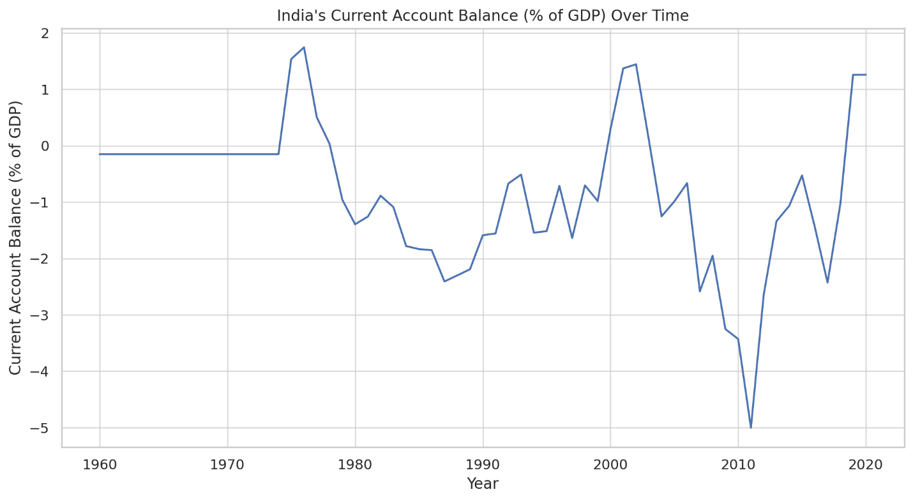

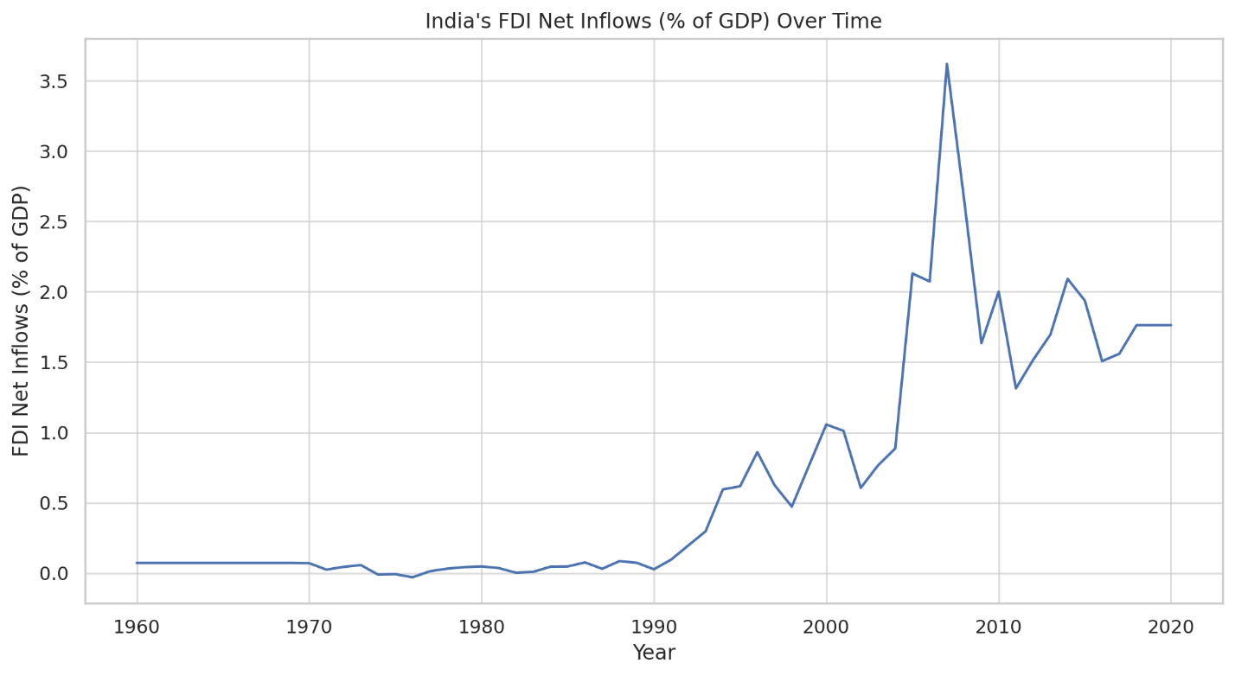

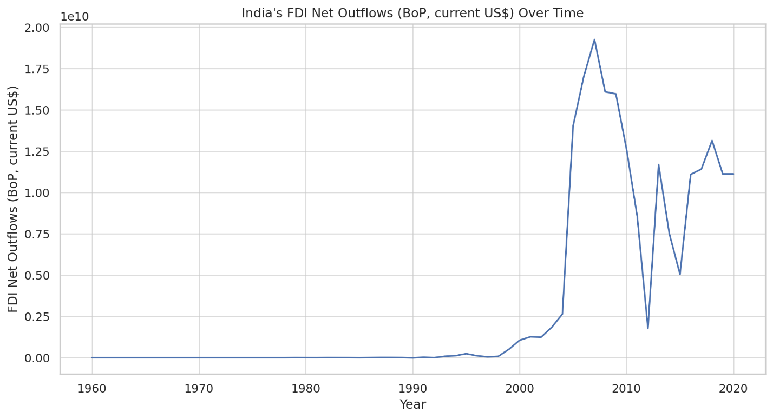

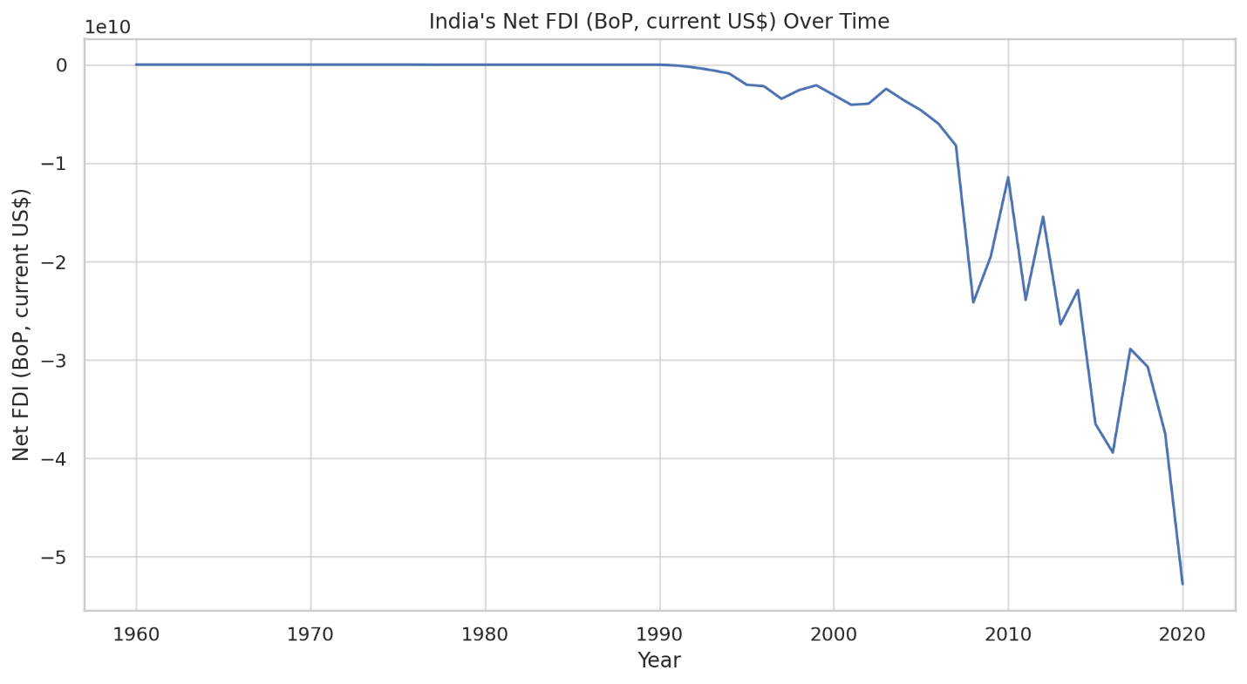

**2. Prompt That We Used:** List Economic Sustainability Statements.

**Shared Chat for Reference:** <https://chat.openai.com/share/aa2490c1-021b-4dfe-88a0-50ec83bada30>

Based on the documents available in my knowledge source, I focused on extracting key economic sustainability statements from the Indian budget speeches over various years. Here's a summary of significant points relevant to economic sustainability from the budget speeches:

**Budget 1947-48:** Emphasized the need for post-independence economic stabilization and development, with a focus on industrial and agricultural growth.

**Budget 1949-50:** Highlighted efforts towards the recovery of the economy post-independence, with attention to both industrial and agricultural sectors for balanced growth.

**Budget 1970-71:** Addressed the importance of self-reliance and the development of agriculture, small-scale industries, and exports as key pillars for sustainable economic growth.

**Budget 1971-72:** Stressed on the significance of agriculture, exports, and the development of small and medium enterprises as essential for economic stability and growth.

**Budget 1990-91:** Discussed measures for economic liberalization and market reforms, with an emphasis on reducing fiscal deficits and encouraging foreign investments.

**Budget 1991-92:** Marked a significant shift towards liberalization, privatization, and globalization. Focused on fiscal consolidation, foreign investment, and trade liberalization as means to achieve economic stability and growth.

**Budget 1992-93:** Continued the focus on economic reforms, liberalization, and measures to attract foreign investment. Emphasized the importance of a stable and efficient financial sector for sustainable economic growth.

**Budget 2020-21:** Focused on contemporary issues like digital economy, sustainable living, and clean energy. Emphasized the importance of technology and innovation in driving sustainable economic growth.

Each budget speech addressed the prevailing economic challenges and outlined the government's approach towards achieving economic sustainability. The focus evolved from post-independence stabilization to liberalization and modern challenges like digitalization and sustainability.

**3. Prompt That We Used:** List Social Sustainability Statements.

**Shared Chat for Reference:** <https://chat.openai.com/share/68b6578c-4ad7-4f74-9e29-722c53109bf4>

Based on the information available in the budget speeches from various years, I can provide insights into social sustainability statements as reflected in India's financial planning and policy. However, it's important to note that a comprehensive analysis covering all aspects of social sustainability across all available budget speeches would require a more detailed and extensive review. Below are some key social sustainability statements and initiatives identified from the budget speeches of different years:

**Budget 1992-93 (bs199293.pdf):**

* Focus on restoring macro-economic balance.
* Emphasis on protecting poorer and weaker sections of society from the impacts of economic adjustments.
* Introduction of a National Renewal Fund to support workers affected by industrial restructuring.
* Commitment to continued funding and revamping of various poverty alleviation schemes.
* Establishment of a Small Farmers' Agri-Business Consortium to promote income and employment in rural areas.

**Budget 1991-92 (bs199192.pdf):**

* Acknowledgment of the challenges in balancing fiscal constraints with social welfare needs.
* Importance given to health and family welfare programs.
* Emphasis on education, particularly primary and secondary education.
* Focus on providing basic amenities and services in rural areas.
* Support for programs addressing the needs of women, children, and socially disadvantaged groups.

**Budget 1971-72 (bs197172(I).pdf):**

* Priority given to agriculture and rural development.
* Attention to employment generation and poverty alleviation.
* Stress on improving the quality of life in rural areas through better amenities and services.
* Focus on social sectors like health and education.
* Measures for land reforms and agricultural productivity enhancement.

**Budget 1947-48 (bs194748.pdf):**

* Post-independence focusses on rebuilding and restructuring the economy.
* Emphasis on agricultural development as a means to ensure food security.
* Prioritization of industrial development for self-reliance and job creation.
* Stress on equitable distribution of resources and benefits of growth.

**Budget 1949-50 (bs194950.pdf), Budget 1990-91 (bs199091.pdf), Budget 2020-21 (bs202122.pdf):**

These budget speeches would also contain relevant information on social sustainability, but a detailed analysis of these documents is needed to extract specific statements and initiatives.

In summary, social sustainability in India's budget speeches has consistently focused on poverty alleviation, rural development, protection of vulnerable sections of society, and balancing economic growth with social welfare. However, this summary is based on a limited analysis and a more thorough examination of all available budget speeches would provide a more comprehensive understanding of India's approach to social sustainability over the years.

**4. Prompt That We Used:** How Farmers benefit from the budget?

**Shared Chat for Reference:** <https://chat.openai.com/share/7f916862-68f1-44ac-b67a-dcd69520fae2>

**5. Prompt That We Used:** Social Security

**Shared Chat for Reference:** <https://chat.openai.com/share/be94bb81-5d0b-481d-bac7-dcacf3244ce2>

**6. Prompt That We Used:** Rural Development

**Shared Chat for Reference:** <https://chat.openai.com/share/35b4d1e9-533b-4c34-b447-83e9b1075b80>

**7. Prompt That We Used:** What are poverty reduction strategies?

**Shared Chat for Reference:** <https://chat.openai.com/share/60bd95b5-6738-45dd-a150-8a3186663496>